INDIVIDUAL LAB-WORK RECORD
ASSIGNMENT 3
Scenario 3: Selenium Page Object Model in the Python Behave Framework
Student Name | ________________________
Roll No. | ________________________
Module | Page Object Model / Maintainable Web Automation
Experiment | Scenario 3: Selenium Page Object Model in the Python Behave Framework
Date | ________________________

1. Problem Statement
To implement Selenium web automation in a Python Behave project using the Page Object Model (POM), thereby separating page locators and page actions from BDD step definitions.

2. Objective
- Understand the Page Object Model design pattern.
- Create a reusable page class containing locators and actions.
- Use the page object from Behave step definitions.
- Reduce duplicated Selenium code.
- Demonstrate a maintainable Gherkin-to-page-object automation flow.

3. Theory
In Page Object Model, each page or important component is represented by a class. The class stores element locators and exposes methods such as enter_username(), enter_password() and click_login(). Behave step definitions call these methods instead of directly containing Selenium locators. If a UI locator changes, it can usually be corrected in the page class without rewriting every scenario.
- Page class encapsulates locators and page operations.
- Feature file contains business-readable behaviour.
- Step definitions connect Gherkin to page-object methods.
- Centralized locators improve maintainability.
- Reusable page methods reduce duplication.

4. Tools, Software and Concepts Used
- Python
- Behave
- Selenium WebDriver
- PyCharm
- Gherkin
- Page Object Model
- CSS/ID locators
- Assertions

5. Project Structure

5.1 Folder Structure
assignment3/
└── features/
├── login.feature
├── environment.py
├── pages/
│ └── login_page.py
└── steps/
└── login_steps.py

6. Implementation

6.1 Page Object - login_page.py
from selenium.webdriver.common.by import By
class LoginPage:
USERNAME = (By.ID, "username")
PASSWORD = (By.ID, "password")
LOGIN = (By.CSS_SELECTOR, "button[type='submit']")
def __init__(self, driver):
self.driver = driver
def enter_username(self, username):
self.driver.find_element(*self.USERNAME).send_keys(username)
def enter_password(self, password):
self.driver.find_element(*self.PASSWORD).send_keys(password)
def click_login(self):
self.driver.find_element(*self.LOGIN).click()

6.2 Feature File - login.feature
Feature: Login using Page Object Model
Scenario: Submit login credentials
Given the login page is displayed
When I enter username "tomsmith"
And I enter password "SuperSecretPassword!"
And I submit the login form
Then the secure page should be displayed

6.3 Step Definitions - login_steps.py
from behave import given, when, then
from selenium import webdriver
from features.pages.login_page import LoginPage
@given("the login page is displayed")
def open_login(context):
context.driver = webdriver.Chrome()
context.driver.get("https://the-internet.herokuapp.com/login")
context.login = LoginPage(context.driver)
@when('I enter username "{username}"')
def enter_user(context, username):
context.login.enter_username(username)
@when('I enter password "{password}"')
def enter_pass(context, password):
context.login.enter_password(password)
@when("I submit the login form")
def submit(context):
context.login.click_login()
@then("the secure page should be displayed")
def verify(context):
assert "/secure" in context.driver.current_url

6.4 Cleanup - environment.py
def after_scenario(context, scenario):
if hasattr(context, "driver"):
context.driver.quit()

7. Execution Steps
- Install Selenium and Behave.
- Create the page, steps and feature files in the shown structure.
- Run `behave`.
- Observe that Gherkin steps call page-object methods.
- Verify navigation to the secure page.
- Capture browser and terminal output.

8. Output Screenshot 1 - Login / Secure Page
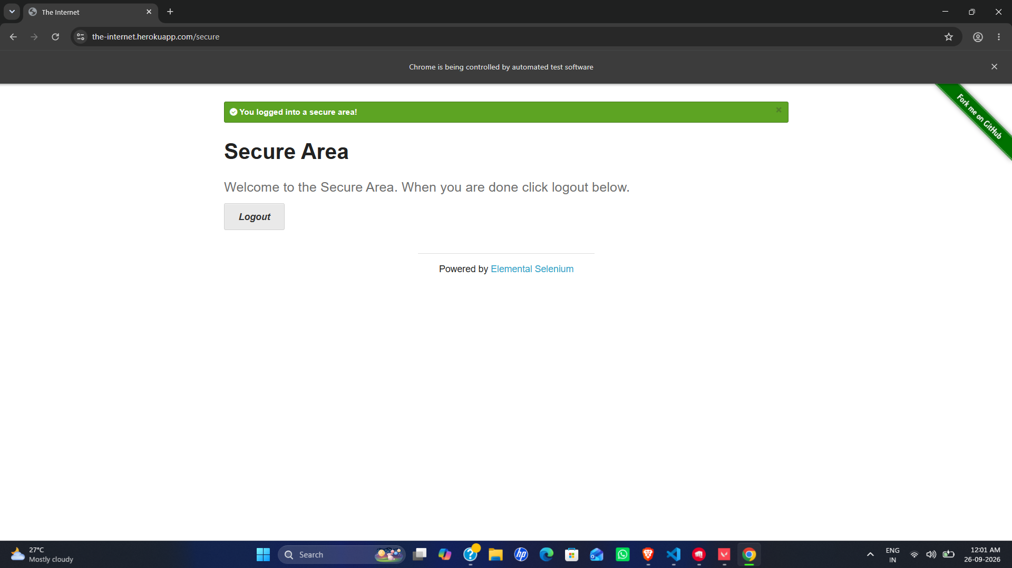

9. Output Screenshot 2 - Behave POM Execution
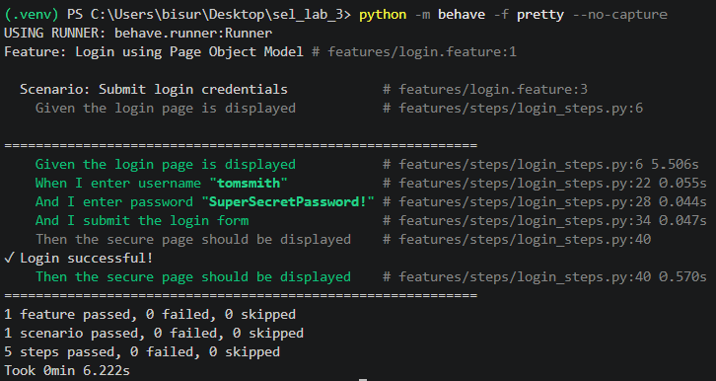

10. Expected Output
The browser should open the login page, submit the configured credentials and reach the secure page. Behave should mark the scenario steps as passed when the target site is reachable and unchanged.

Result
A Selenium Page Object was successfully integrated with Behave step definitions for a reusable login workflow.

Observation
The Selenium locators are centralized in LoginPage, while the step file remains concise and readable. This structure is easier to update than embedding locators throughout the test suite.

Conclusion
The experiment demonstrates that POM improves modularity, readability and maintainability of Selenium Behave automation.

